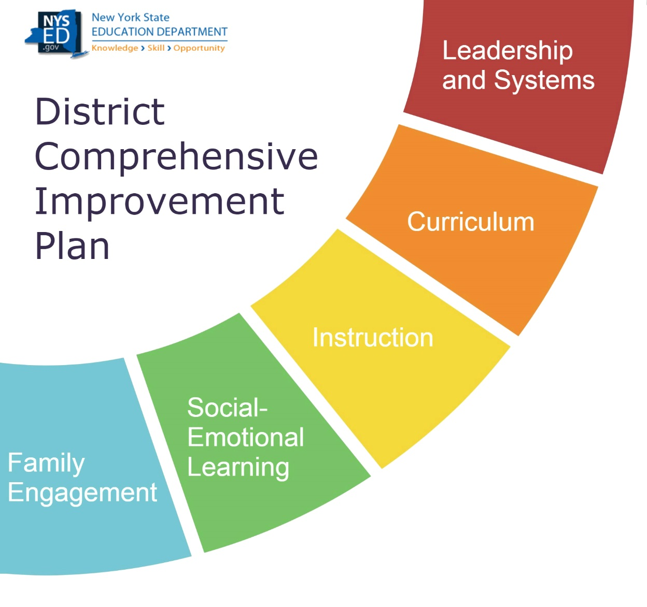

DCIP Planning Document for 2022-23 DCIP

|  |
| --- |
| District |
| *Evans-Brant (Lake Shore) Central School District* |

A Message to District Leaders:

The District Comprehensive Improvement Plan (DCIP) Planning Document is designed to help districts consider the conditions within the District that need attention when developing the 2022-23 DCIP.

The DCIP Planning Document provides the District with the opportunity to reflect on the way in which the schools within the District are organized to promote achievement. While this document is intended to serve as a foundation for the DCIP, NYSED strongly encourages districts to take a deeper look at relevant data across the District to best support the District’s ability to identify specific solutions for their unique needs. This document will involve:

* Evaluating the impact of COVID-19
* Considering the effectiveness of the 2021-22 DCIP
* Understanding local data
* Reviewing the District’s vision, values, and aspirations

NYSED encourages districts to be strategic in how they address their needs and to be mindful of the number of priorities and changes they attempt to address each year. When developing your 2022-23 DCIP, consider ways the Priorities intersect so that the DCIP is aligned to support the pressing needs of the District. Rather than identifying multiple independent Priorities within the DCIP, consider ways that Priorities could be supported through a strategic approach that allows for the work being done in one area to support the work being done in another area.

Contents

Section 1: Considering What was Learned in 2021-22 3

Evaluating the Impact of COVID-19 3

Evaluating the Success of the 2021-22 DCIP 3

Considering the Effectiveness of Previous Resource Decisions 5

Understanding Local Data 6

Listening to Students 7

Examining Equity 7

Section 2: District’s Vision, Values, and Aspirations 9

Section 3: Putting it all together 10

Priority 1: 10

Priority 2: 10

Priority 3: 10

Priority 4 (if applicable) 11

Priority 5 (if applicable): 11

NEXT STEPS 11

# Section 1: Considering What was Learned in 2021-22

## Evaluating the Impact of COVID-19

|  |
| --- |
| What needs have been identified as a result the COVID-19 pandemic? |
| * *Teachers maintained triage and remained highly responsive to unpredictable shifts in curriculum, instructional modes, and assessment approaches. This made it difficult to maintain alignment to the scope and sequence of grade and content level specific curricula.* * *Gathering meaningful data relevant to academic performance was difficult, as attendance was inconsistent, technologies didn’t always perform as needed, assessments could not be deployed in a remote setting as they were in person, and teachers’ focus on professional learning and growth as well as the design of new assessments was significantly disrupted.* * *District efforts to align curricula, instructional practices, and assessments—which had begun in earnest prior to COVID19—were also significantly compromised.* * *Learners missed opportunities to establish nurturing relationships with peers, teachers, administrators, and coaches through in-person learning and socialization.* * *Learners missed opportunities to deepen their cultural awareness of those who are different from them by engaging with peers, teachers, and community members outside of their homes and close family and social circles.* * *Routine was lacking, and when it was established, it was often disrupted.* * *Students grappled with unforeseen trauma as a result of the virus, its physical impact on loved ones, and the resulting loss of jobs and stress on relationships.* * *Opportunities to move through healthy phases of norming, storming, forming, and performing as learning communities inside of classrooms, on teams, and in extra-curricular groups were significantly compromised. These are natural phases of group formation that result in healthy learning communities and form the foundation of collaborative learning, problem-solving, and growth. In the absence of this, it is difficult for groups to pursue significant shifts in learning or practice*. |
| To what extent is the identified subgroup(s) disproportionally impacted by the issues identified in the previous response? |
| * *26% of students in the identified subpopulation were fully remote learners in 20-21.* * *22% of students in the identified subpopulation transferred out of the district during this time.* * *81% of students in the identified subpopulation live in poverty.* * *Over half of these students also have incomplete assessment records due to absence or test refusal.* * *The identified subgroup entered the year at a significant disadvantage in terms of performance, and the issues above undermined the district’s attempt to offer learners a rigorous, guaranteed and viable curricula. Lack of alignment in curriculum, instructional practices, and assessment—along with teachers’ inability to gather and then, meet to analyze and respond to quality data—means that this population has not yet had focused interventions. They are now in grades 7-11.* * *Most significantly, it is difficult to clearly understand the extent to which the identified subgroup was disproportionally impacted by these issues because we do not yet have solid evidence that might help us draw meaningful conclusions.* |
| What has the District learned through its efforts to address these needs? |
| * *Establishing expectations and clear articulated curriculum with an expectation of fidelity is become increasingly apparent. Combining that with integrated daily social and emotional learning practices is a priority.* |
| How will these lessons learned be incorporated in the 2022-23 DCIP? |
| * *The district has partnered with an outside educational council to analyze our data, our planning practices and our cycle of review to assist in creating a strategic plan that addresses all aspects of daily instructional priorities – curriculum articulation, implementation and assessment, implementation of social and emotional invested practices and compliance with procedures and policies that keep our school safe and healthy.* |

## Evaluating the Success of the 2021-22 DCIP

Refer to the 2021-22 DCIP to complete the information below.

|  |
| --- |
| Priority 1 in 2021-22 DCIP: |
| Was the District able to achieve the End-of-Year Outcomes identified for this Priority? |
| If the identified outcomes were not achieved, in the space below, identify factors that may have contributed to the District not achieving these outcomes. |
| Factors |
| *The priority was to establish grade level and discipline PLCs to use data to inform practice and develop assessments to inform instruction.* |
| * *This occurred at the high school. Departments set priorities, developed assessments to assess those priorities and analyzed the data.* |
|  |
|  |

|  |
| --- |
| Priority 2 in 2021-22 DCIP: |
| Was the District able to achieve the End-of-Year Outcomes identified for this Priority? |
| If the identified outcomes were not achieved, in the space below, identify factors that may have contributed to the District not achieving these outcomes. |
| Factors |
| *The priority was to create standards-based formative and summative assessment design.* |
| * *Our priority, while valuable, shifted greatly this year. We were overcome with social and emotional needs of staff and students. While formative assessments were created in some high school departments, this did not occur district-wide.* |
|  |
|  |

|  |
| --- |
| Priority 3 in 2021-22 DCIP: |
| Was the District able to achieve the End-of-Year Outcomes identified for this Priority? |
| If the identified outcomes were not achieved, in the space below, identify factors that may have contributed to the District not achieving these outcomes. |
| Factors |
| *Priority 3 was attending to social emotional health of students and staff. Four of the five buildings created PLCs to attend to social and emotional health of students and staff. All staff are being trained in Youth Mental Health First Aid. We are halfway through meeting our goal. Consultants, Pete Hall and Kristen Souers, hosted a workshop for our administrators. Kristen will be our keynote speaker in August 2022. Her work will be carried throughout the year and customized to meet the needs of the building. Second Step, a K-8 research-based curriculum is being fully implemented in K-5. 6-8 has the materials. We have hired one new social worker, an additional counselor and have plans to hire one more social worker for 22-23. CPI training continues to be provided so that faculty and staff feel equipped to de-escalate behavior situations in our classrooms and buildings.* |
|  |
|  |
|  |

|  |
| --- |
| Priority 4 in 2021-22 DCIP (if applicable): |
| Was the District able to achieve the End-of-Year Outcomes identified for this Priority? |
| If the identified outcomes were not achieved, in the space below, identify factors that may have contributed to the District not achieving these outcomes. |
| Factors |
| NA |
|  |
|  |
|  |

|  |
| --- |
| Priority 5 in 2021-22 DCIP (if applicable): |
| Was the District able to achieve the End-of-Year Outcomes identified for this Priority? |
| If the identified outcomes were not achieved, in the space below, identify factors that may have contributed to the District not achieving these outcomes. |
| Factors |
| NA |
|  |
|  |
|  |

|  |
| --- |
| After reviewing your success in achieving the 2021-22 DCIP Priorities, what lessons have you learned that can be incorporated into your 2022-23 DCIP |

## Considering the Effectiveness of Previous Resource Decisions

Identify the top three areas where the District directed its 2021-22 Title 1 1003(a) District-level Improvement Funds.

|  |
| --- |
| #1 Recipient/Use of District Improvement Funds: Hired a Teaching Assistant to collaborate with AIS teachers to provide direct interventions to students identified in our DCIP. |
| What was your goal in directing funds in this manner? The goal was to accelerate learning by providing small group or individualized instruction in identified academic needs. |
| Have you met this goal? How do you know? The Teaching Assistant worked with middle school students primarily in the area of math. Data was collected using our universal screening tool in ELA and Math. Students are learning and we have identified those who need further Tier supports. |
| What **practices (including student practices and teacher practices)** look different in the District now as a result of this expenditure?  The Teaching Assistant, along with the AIS Math teacher, are collecting data, analyzing it, and meeting with 6-8 math teachers with their findings in hopes to gather more formative assessment data as a norm in the 22-23 school year. |
| #2 Recipient/Use of District Improvement Funds: A current assistant principal was paid a stipend to oversee and implement the goals. |
| What was your goal in directing funds in this manner? The goal was to accelerate the process by having an onsite administrator meeting with teachers on a regular basis to monitor the implementation of the data collection, teacher meetings and the caseload of the teaching assistant. |
| Have you met this goal? How do you know? The onsite administrator did monitor the implementation. We were overwhelmed by student and staff social and emotional needs so this goal was partially met because we do have evidence of teacher meetings, data collection, a teaching assistant providing interventions and collecting data and informing instruction with that data furthering the need for more assessment data collection. |
| What **practices (including student practices and teacher practices)** look different in the District now as a result of this expenditure?  Our teaching assistant, after year one, is more confident in data collection, providing tier supports and sharing results in teacher meetings. |
| #3 Recipient/Use of District Improvement Funds: We used the funds to host a consultant who is a social worker by trade, an author and a national consultant. We used funds to buy her books as well. |
| What was your goal in directing funds in this manner? Our goal was to continue the learning of social emotional learning, trauma-invested work, and trauma-informed instruction to further build capacity for our adults to help our students. |
| Have you met this goal? How do you know? The goal is ongoing. The consultant worked with our administrators in June and will come back to work with teachers in August with follow-up next year. |
| What **practices (including student practices and teacher practices)** look different in the District now as a result of this expenditure? Adults are becoming more and more attuned to how to attend students who may be struggling emotionally. Elementary classrooms have calming corners. One building is working on building stronger relationships amongst faculty. Another building is using a monthly newsletter and social media to transfer student learning about regulation and other strategies to home. |

|  |
| --- |
| After considering the effectiveness of previous resource allocation decisions, what lessons have you learned that can be incorporated into your 2022-23 DCIP?  We will establish a stronger district-wide intention around social and emotional well-being of all stakeholders with an organizational vision of the plan and implementation timeline.  We will partner with an educational council to help us to strategically plan for curriculum articulation 6-12.  We will hire an elementary teacher leader to facilitate the development of a K-5 writing curriculum based on data from 3-8 assessments, classroom performance, summative assessments and universal screening.  All 6-12 departments will articulate their curriculum. |

## Understanding Local Data

Use the space below to include at least five local data points that the District has collected that are relevant to understanding the District. These could include:

* State-collected data from the NYSED District Report Card, such as the teacher turnover rate
* District-collected data, such as survey results
* Districtwide academic assessment data
* Student engagement/attendance data
* Student social-emotional health data

When possible, consider data from the 2021-22 school year.

Example: *District survey data indicated that 44% of students say that they do not feel challenged in class.*

|  |
| --- |
| District-level Data |
| We are below 50% proficiency in 3-8 in all grade levels and all subgroups. |
| Participation rate in 3-8 state testing is increasing but we are still below the 95% participation rate. |
| We hired 43 new instructional staff members in 21-22. We anticipate hiring 17 instructional staff for the 22-23 school year. |
| 75% of our students participate in the Panorama survey. |
| Almost 20% of our student population at the high school is chronic in their absenteeism. Over 32% of our Native American students were chronically absent in 21-22. |

## Listening to Students

Identified schools are interviewing students in advance of writing their annual plans, and Districts with identified schools are being asked to reflect on the feedback provided by students as part of their DCIP. Districts without identified schools are welcome to pursue Student Interviews as well, and may find the resource below helpful: <http://www.nysed.gov/common/nysed/files/programs/accountability/interviewing-students-in-advance-of-developing-the-scep_2.pdf>

|  |
| --- |
| If your District conducted Student Interviews, what themes emerged from this process? If no interviews were conducted, the District may leave this section blank. |
| NA |

## Examining Equity

Identified schools are completing an Equity Self-Reflection in advance of writing their annual plans, and Districts with identified schools are being asked to consider the discussions that occurred within their identified schools when developing their DCIP. Districts without identified schools are welcome to incorporate the Equity Self-Reflection into their DCIP as well, and may find the resource below helpful: <http://www.nysed.gov/common/nysed/files/programs/accountability/equity-self-reflection-for-2022-23-scep.docx>

|  |
| --- |
| If schools within your District completed the Equity Self-Reflection, what themes emerged from this process? If schools did not complete this document, the District may leave this section blank. |
| NA |

# Section 2: District’s Vision, Values, and Aspirations

|  |
| --- |
| 1. What is the District’s vision? |
| The Lake Shore Central School District in partnership with our students, families and school community will cultivate engaging, diverse, and challenging educational opportunities and learning environments to promote life-long learning and achievement in preparation for high school graduation, college and careers. |
| 1. In recognition that sometimes vision statements may not be a current reflection of the District’s values and aspirations, is there anything else important to know about what the District values and aspires to be that is not captured in the current vision? |
| We want to increase our academic expectations for students, and within that, we want to ensure that we are trauma-invested, culturally responsive and engaging for all students. |
| 1. Review your responses to Section 1. What themes emerge that let you know that you have made progress toward the vision, values, and aspirations of the District? |
| We continue to provide professional development for our staff in trauma-informed work including our consultant in August. We continue to strive for the academic excellence be evidence of hiring a teaching assistant to support math interventions. Our chronic absenteeism is an item for concern. |
| 1. Review your responses to Section 1. What themes emerge that let you know that you still have work to be done toward the vision, values, and aspirations of the District? |
| There is not a clear articulated curriculum K-12. With an increase in retirements including in our administrative team, we have to reset and ensure that the social and emotional pieces are embedded in all the work that we do. |
| 1. If Student Interviews were conducted, what themes emerged through the Student Interviews that let you know that you have made progress toward the vision, values, and aspirations of the District? What themes emerged that let you know that you still have work to be done toward the vision, values, and aspirations of the District? Districts that did not conduct Student Interviews may leave this section blank. |
| NA |
| 1. If the Equity Self-Reflection for Identified Schools was completed within your District, what themes emerged that let you know that you have made progress toward the vision, values, and aspirations of the District? What themes emerged that let you know that you still have work to be done toward the vision, values, and aspirations of the District? Districts that did not complete the Equity Self-Reflection for Identified Schools may leave this section blank. |
| NA |

# Section 3: Putting it all together

**Review your responses to sections 1 and 2** to identify 3 to 5 priorities for the 2022-23 DCIP. Identify the priorities below and indicate how those priorities support the themes that emerged in the previous sections.

## Priority 1:

|  |  |
| --- | --- |
| What will the District prioritize to extend success in 2022-23? | Over the course of two years, a clear, articulated curriculum 6-12 by subject and department and a clear articulated writing curriculum K-5 |

This Priority helps support (indicate all that apply)

Impact of COVID-19 (Section 1 – Evaluating the Impact of COVID-19)

Recent Data (Section 1 – Understanding Local Data)

The District’s Vision (Section 2, Question 1)

xThe District’s Values and Aspirations not captured through Vision (Section 2, Question 2)

Themes from Student Interviews (Section 2, Question 5)

Themes from the Equity Self-Reflection (Section 2, Question 6)

## Priority 2:

|  |  |
| --- | --- |
| What will the District prioritize to extend success in 2022-23? | A clear articulated SEL plan K-12 that is shared with a timeline |

This Priority helps support (indicate all that apply)

xImpact of COVID-19 (Section 1 – Evaluating the Impact of COVID-19)

Recent Data (Section 1 – Understanding Local Data)

xThe District’s Vision (Section 2, Question 1)

xThe District’s Values and Aspirations not captured through Vision (Section 2, Question 2)

Themes from Student Interviews (Section 2, Question 5)

Themes from the Equity Self-Reflection (Section 2, Question 6)

## Priority 3:

|  |  |
| --- | --- |
| What will the District prioritize to extend success in 2022-23? | A strategic plan to increase student learning, reduce chronic absenteeism and to serve our staff, students and community in mental health support |

This Priority helps support (indicate all that apply)

xImpact of COVID-19 (Section 1 – Evaluating the Impact of COVID-19)

xRecent Data (Section 1 – Understanding Local Data)

xThe District’s Vision (Section 2, Question 1)

xThe District’s Values and Aspirations not captured through Vision (Section 2, Question 2)

Themes from Student Interviews (Section 2, Question 5)

Themes from the Equity Self-Reflection (Section 2, Question 6)

## Priority 4 (if applicable)

|  |  |
| --- | --- |
| What will the District prioritize to extend success in 2022-23? | NA |

This Priority helps support (indicate all that apply)

Impact of COVID-19 (Section 1 – Evaluating the Impact of COVID-19)

Recent Data (Section 1 – Understanding Local Data)

The District’s Vision (Section 2, Question 1)

The District’s Values and Aspirations not captured through Vision (Section 2, Question 2)

Themes from Student Interviews (Section 2, Question 5)

Themes from the Equity Self-Reflection (Section 2, Question 6)

## Priority 5 (if applicable):

|  |  |
| --- | --- |
| What will the District prioritize to extend success in 2022-23? | NA |

This Priority helps support (indicate all that apply)

Impact of COVID-19 (Section 1 – Evaluating the Impact of COVID-19)

Recent Data (Section 1 – Understanding Local Data)

The District’s Vision (Section 2, Question 1)

The District’s Values and Aspirations not captured through Vision (Section 2, Question 2)

Themes from Student Interviews (Section 2, Question 5)

Themes from the Equity Self-Reflection (Section 2, Question 6)

# NEXT STEPS

You have now completed the DCIP planning document. When developing your 2022-23 DCIP, please take into consideration your reflection on the District’s vision, values, and aspirations and what the District learned from the past school year to determine the best strategies to pursue. The Priorities identified in this document should correspond with the Priorities in your DCIP.

**Please submit this document to** [dcip@nysed.gov](mailto:dcip@nysed.gov) **when you submit your 2022-23 DCIP.**